

**Charkhi Dadri Mid-Air Collision**

12-11-1996

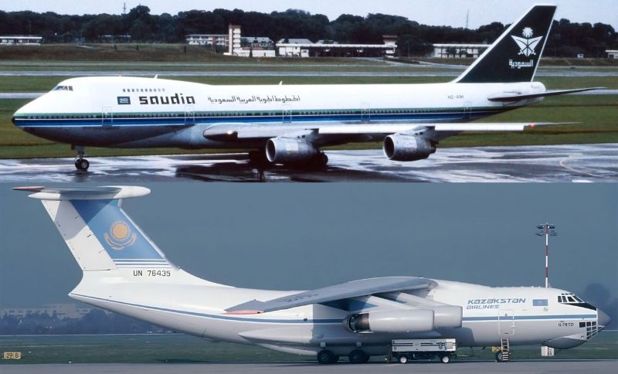

REport by:

Arpit maurya

3rd Sem EEE

Batch 06 : Aviation Domain at MARVEL, UVCE

Table of Contents

1. Introduction.2

2. Aircraft Details2

3. Pilot Details………………………………………………………………………………………………………………….…………… 2

4. Crew Members and Passengers…………………………………………………………………………………………………..3

5. Background…………………………………………………………………………………………………………………………………3

6. Swiss Cheese Model……………………………………………………………………………………………………………………4

7. Lessons Learned……………………………………………………………………………………………………………….…………4

1. **Introduction**

The **Delhi mid-air collision** (12 November 1996) occurred near Charkhi Dadri, Haryana, when a **Saudi Arabian Airlines Boeing 747** departing Delhi and climbing to 14,000 feet collided with a **Kazakhstan Airlines Ilyushin Il-76** descending toward Delhi and instructed to remain at 15,000 feet. Due to **miscommunication** and the Kazakh crew’s limited English proficiency, the Il-76 descended below its assigned altitude, striking the 747’s wing and causing both aircraft to break apart mid-air, killing all **349 people** on board.

1. **Aircraft Details**

**2.1 Saudi Arabian Airlines Flight 763**

* **Aircraft type:** Boeing 747-168B
* **Registration:** HZ-AIH
* **Operator:** Saudi Arabian Airlines (Saudia)
* **Flight route:** New Delhi (India) → Dhahran (Saudi Arabia) → Jeddah (Saudi Arabia)

**2.2 Kazakhstan Airlines Flight 1907**

* **Aircraft type:** Ilyushin Il-76TD (four-engine cargo/transport aircraft)
* **Registration:** UN-76435
* **Operator:** Kazakhstan Airlines
* **Flight route:** Shymkent (Kazakhstan) → New Delhi (India)

1. **Pilot Details**

**3.1 Saudi Arabian Airlines Flight 763 (Boeing 747-168B)**

*Captain: Khalid Al-Shubaily*

* **Age:** 45
* **Nationality:** Saudi Arabian
* **Experience:** Over **9,800 flight hours** (including 3,700+ hours on the Boeing 747).
* **Notes:** He was an experienced captain and correctly followed Air Traffic Control (ATC) instructions to climb to **14,000 ft** after takeoff from Delhi.
  1. **Kazakhstan Airlines Flight 1907 (Ilyushin Il-76TD)**

*Captain: Alexander Cherepanov*

* **Age:** 44
* **Nationality:** Kazakhstani
* **Experience:** Over **9,200 flight hours** (mostly on Ilyushin aircraft).
* **Notes:** The cockpit crew had **limited English proficiency**. Communication with ATC was done through a **radio operator/translator** instead of the pilots themselves, which delayed and distorted instructions.
* **Radio Operator (Key Role):**
  + Name not widely published, but he acted as the **interpreter between ATC (English)** and the Kazakh pilots (who mainly spoke **Russian**).
  + Misinterpretation and slow relay of ATC instructions contributed directly to the descent below the assigned altitude.

**4.** **Crew Members and Passengers**

**4.1 Saudi Arabian Airlines Flight 763 (Boeing 747-168B, HZ-AIH)**

* Total onboard: 312
* Passengers: 289
* Crew: 23
* Fatalities: 312 (no survivors)
* Passenger details:
* Most were Indian nationals, flying to Saudi Arabia for work (migrant workers, many from Kerala and other states).
* Some Saudi nationals and other foreigners were also on board.
* Crew details:
* 1 Captain (Khalid Al-Shubaily)
* 1 First Officer
* 21 Cabin crew members (Saudi and other nationalities).

**4.2 Kazakhstan Airlines Flight 1907 (Ilyushin Il-76TD, UN-76435)**

* Total onboard: 37
* Passengers: 10
* Crew: 27
* Fatalities: 37 (no survivors)
* Passenger details:
* A mix of Kazakh and Russian nationals.
* Included airline staff and a few family members of crew.
* Crew details:

1 Captain (Alexander Cherepanov)

* 1 Co-pilot
* 1 Flight engineer
* 1 Navigator
* 1 Radio operator (handled ATC communication)
* 22 additional support crew members.

**5. Background**

The **Charkhi Dadri mid-air collision** occurred on 12 November 1996 near Charkhi Dadri, Haryana, when a Saudi Arabian Airlines Boeing 747 departing Delhi and a Kazakhstan Airlines Ilyushin Il-76 approaching the city collided at 14,000 feet, killing all 349 people on board both aircraft. At the time, Delhi’s airspace was heavily congested, with inbound and outbound flights sharing the same corridor but at different altitudes. The Saudi aircraft correctly climbed to 14,000 feet as instructed, while the Kazakh aircraft was told to maintain 15,000 feet but, due to miscommunication between its Russian-speaking crew and Air Traffic Control, it descended to 14,000 feet instead. Neither aircraft was equipped with TCAS (Traffic Collision Avoidance System), which could have prevented the crash, and ATC realized the error too late. The collision, caused by language barriers, lack of modern safety systems, and inadequate airspace design, led to the deadliest mid-air crash in history and resulted in sweeping reforms in Indian aviation, including mandatory TCAS installation, redesigned air corridors, and stricter English proficiency standards for pilots.

**6. Swiss Cheese Layers**

* 1. **Airspace Design (Organizational Level)**
* Delhi had a single airway for both incoming and outgoing flights.
* Only vertical separation (altitude differences) was used, leaving no redundancy if altitude was mismanaged.
  1. **Technology Limitations (Latent Condition)**
* Neither aircraft had TCAS (Traffic Collision Avoidance System**)**, which could have issued automatic avoidance instructions.
* Radar coverage and ATC tools were limited compared to modern standards.
  1. **Communication Barrier (Unsafe Supervision)**
* The Kazakh crew spoke Russian, while ATC spoke English.
* A radio operator acted as a translator, introducing delays and misinterpretation.
  1. **Human Error (Active Failure)**
* The Kazakh crew descended to 14,000 ft instead of staying at 15,000 ft, violating ATC instructions.
* Situational awareness was poor in the cockpit, as the crew misunderstood their clearance.
  1. **ATC Limitations (Defense Barrier Gap)**
* The controller noticed the altitude violation **too late** to intervene.
* No automated conflict detection/warning systems were in place.

According to the Swiss Cheese Model, the crash happened not due to a single mistake but because organizational flaws, technology gaps, language barriers, human errors, and late ATC intervention all aligned, removing every safety net and allowing the disaster.

**7. Theories and Assumptions**

During the investigation of the **Charkhi Dadri mid-air collision (1996)**, several theories and assumptions were examined before the final cause was established. Initially, investigators considered whether Delhi Air Traffic Control (ATC) had made an error, but transcripts confirmed that instructions were clear: the Saudi aircraft was cleared to climb to 14,000 ft while the Kazakh aircraft was told to maintain 15,000 ft. The possibility of Saudi pilot error was also eliminated after flight recorder data showed the Boeing 747 was at its correct assigned altitude.

Attention then shifted to the Kazakh crew, and evidence from radar and black box recordings confirmed that their Ilyushin Il-76 had descended to 14,000 ft instead of maintaining 15,000 ft, directly causing the collision. Investigators also explored technical failure, such as altimeter or autopilot malfunction, but found no defects in the aircraft’s systems. Another important factor was communication: the Kazakh crew had limited English proficiency and relied on a radio operator to interpret ATC instructions, leading to misinterpretation and delayed responses. Finally, it was noted that neither aircraft was equipped with TCAS (Traffic Collision Avoidance System), which could have prevented the disaster, but its absence was a systemic issue rather than a failure. In conclusion, the crash was confirmed to have resulted from the Kazakh aircraft’s unauthorized descent, worsened by communication barriers, lack of TCAS, and congested airspace design.

**8. Lessons learned**

**8.1** **Mandatory TCAS Installation**

* The crash showed that Traffic Collision Avoidance Systems (TCAS) are essential. India became the first country to mandate TCAS in all commercial aircraft, a practice later adopted worldwide.

**8.2** **Airspace Redesign**

* Relying on a single corridor for both inbound and outbound flights was unsafe. After the crash, India restructured its airspace with separate routes and altitude layers to minimize head-on conflicts.

**8.3** **Standardized Language in Aviation**

* Miscommunication was a major factor. The accident reinforced English as the universal language of aviation and highlighted the need for pilots to be proficient, not reliant on translators.

**8.4** **Stricter ATC Procedures**

* Air Traffic Control protocols were strengthened to ensure better altitude separation and more proactive conflict detection.